[Skip to main content](https://www.worldpulse.com/en/community/users/bchrd/posts/62424" \l "main-content)

* [Stories](https://www.worldpulse.com/en/story-awards)
* [Changemakers](https://www.worldpulse.com/en/changemakers)
* [About](https://www.worldpulse.com/en/about-us)
* [Give](https://www.worldpulse.com/en/give)
* [Log On](https://www.worldpulse.com/en/my-pulse/login)
* [Join](https://www.worldpulse.com/en/join)

**Adulteration of food in Bangladesh**



[BCHRD](https://www.worldpulse.com/en/community/users/bchrd)

Posted November 4, 2015 from Bangladesh

[Follow Me](https://www.worldpulse.com/en/my-pulse/login?destination=node/62424)

* [8](https://www.worldpulse.com/en/my-pulse/login?destination=community/users/bchrd/posts/62424)

Comment

* [1](https://www.worldpulse.com/en/my-pulse/login?destination=node/62424)

Send Love

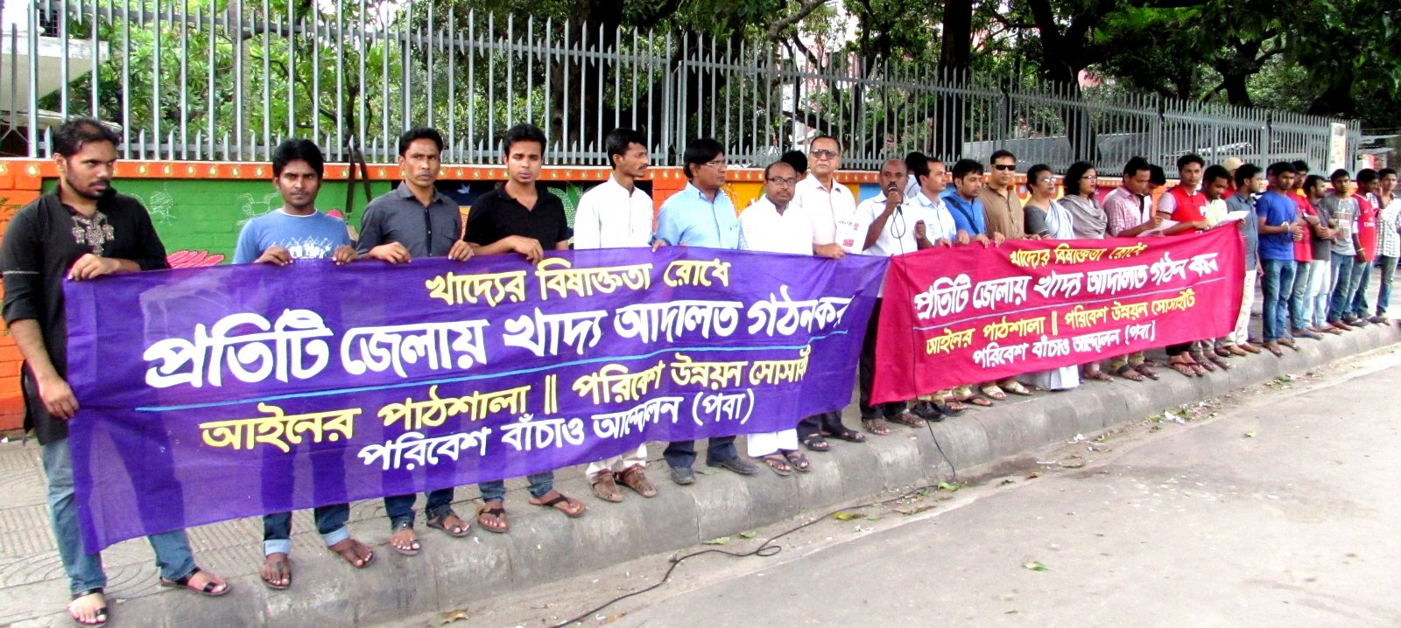Demanding Food Court : Green Activist demanded from Human Chain demanding Food Court at Every District in Bangladesh **(1/1)**

Adulteration of food with toxic chemicals harmful to health has reached an epidemic proportion in Bangladesh. The newspapers have dubbed it as the ‘silent killer’. It is very difficult to find a sector of food industry which is free of adulteration. From raw vegetable and fruits to milk and milk products to fish, meat and processed food–every food item is contaminated. Almost every day in the news papers, newer and newer methods of adulterating newer and newer types of foods are reported. Carbide, formalin, heavy metal, chemical, textile colours, artificial sweeteners, DDT, urea etc. are used rampantly for this purpose. Contamination of foods with toxic chemicals pose a serious threat to public health, especially in a country like Bangladesh where due to poor health literacy, level of awareness is very low. Immediate effect of ingestion of such foods may be severe forms of diarrhoea (food poisoning), threatening life. In the long run, these chemicals in food adversely affect vital organs such as the liver and kidney resulting in organ failure and/or cancer and thus, untimely loss of life. There is no database in the country for these, but the recent surge in liver and kidney failure patients in the hospitals is indicative of the deteriorating situation. Ironically, people from all walks of life is aware of the hazards of taking foods adulterated with toxic chemicals, but this knowledge is not translated into practice. In a recent study, it has been found that though people are aware about the health hazards, they are nevertheless buying and consuming these adulterated foods. Several explanations are made for this paradox; absence or unavailability of non-adulterated food, failure of the regulatory agency to test and screen out adulterated food, adulterated foods are attractive in appearance and costs less, cultural factors and food habits etc. There is no paucity of laws and regulations to contain adulteration of food in Bangladesh such as Bangladesh Standard Testing Institute (BSTI) Ordinance of 1985, and the Pure Food Ordinance of 2005. Under the purview of these rules come the following offences: fake licenses, poor quality of food, substandard infrastructure and lack of maintaining hygiene, food adulteration, food impurity, incorrect information on food packages, selling products whose date have expired etc. However, the problem lies in its sustained and appropriate implementation by credible authority. Occasionally, the regulatory authorities will be suddenly in an active mode, and conduct mobile courts to penalize sellers/producers for selling contaminated products/foods. Then, there will be a lull for a few days and after few weeks, business becomes as usual.

Research Report: A group of health experts and green activists on Monday 06 July 2015 demanded that authorities control the use of pesticide in food production to protect public health. This demand came at press conference on Taking effective measures to control food adulteration organized by POBA at its office. At the press conference, POBA also disclosed a research report which suggests that about ten percent of fruits collected from different part of Dhaka city had high percentage of formalin. About 61 samples of fruits including mangoes, apples, dates, banana, malta, guava, pineapple, cucumber and a number of others were brought to it for formalin test. The duration of this research was a total 25 days which started from 10 June 2015 and continued till 05 July 2015. Another recent research report on examining food items for presence of poisonous elements conducted by Food Security Research (FSR) suggests about that 40 percent of food items carries more than 3-20 percent higher DDT (Dichloro-Diphenyl-Trichloroethane), Aldrin, Chlordane, Heptachlor and other poisonous elements than permissible level. Of them 35 percents of fruits and 50 percents of vegetables had the presence of pesticides, there are 13 samples of rice which had the excessive amount of arsenic and about five rice items had chromium. Abu Naser Khan Chairman of POBA presided over the programme while Engineer Md Abdus Sobhan Executive General Secretary presented the key speech. The press conference presented some recommendation such as implementation of Formalin Control Act 2015 and Safe Food Act 2013, import formalin through trading Corporation of Bangladesh (TCB) and paying heed to people’s demand, forcing industrialists and factory owners to st up Effluent treatment plant, forming food court and employ sufficient food instructors in every district level of Bangladesh and and inspire farmers to use natural fertilizers instead of pesticides. A section of unaware farmers, greedy traders and suppliers are using chemicals, pesticide and toxic subroutines in food and fruits items. DDT, aldrin, chlordane and heptachlor etc is severely poisonous to health . Unchecked use of pesticide in agriculture is posing a threat to public health. A section of unscrupulous traders use these chemicals in fruits to keep them fresh for long, which adversely affects human health.

[South and Central Asia](https://www.worldpulse.com/en/search?f%5B0%5D=field_taxonomy_country%3A7)[Environment](https://www.worldpulse.com/en/search?f%5B0%5D=field_taxonomy_topic%3A9)

**Comments 8**

[**Log in**](https://www.worldpulse.com/en/my-pulse/login?destination=node/62424) **or** [**register**](https://www.worldpulse.com/en/signup?destination=node/62424) **to post comments**

BCHRD

Nov 04, 2015

[BCHRD](https://www.worldpulse.com/en/community/users/bchrd)

Activities: Two Demonstration Activities will be organized at Dhaka to stop food Adulteration in Bangladesh to establish Safe Food Law 2013.

First and foremost, to ensure commitment from the political establishment to wage a sustained campaign against these perpetrators of heinous crime, and establish our fundamental right to have safe and nutritious food! For this to achieve, relentless enforcement of existing laws like safe food laws 2013 with the execution of highest penalty possible, awareness-building campaign among consumers, to ensure promotion of ethical practices among the business community with active involvement of the business leaders, and capacity development of public health labs to test food items for adulteration on the spot are needed. The consumer rights groups should be more vocal and play active role in developing a mass campaign/movement in the country.

Safe and unadulterated food is out human right!...Let’s work together to achieve this. For more: Hossain et al. (2008). Consumption of foods and foodstuffs processed with hazardous chemicals: a case study of Bangladesh. International Journal of Consumer Studies 32: 588–595. Huda et al. (2009). An enquiry into the perception on food quality among urban people: a case of Bangladesh. African Journal of Business management 3: 227-232

Nusrat Ara

Nov 10, 2015

[Nusrat Ara](https://www.worldpulse.com/en/community/users/nusrat-ara)

We need for awareness and actvisim related to food Adulteration . I see people aren't knowing what is in the food that they eat and also we have to explore alternatives.

Victoria Green

Nov 12, 2015

[Victoria Green](https://www.worldpulse.com/en/community/users/victoria-vorosciuc)

It is great to know how you organisation -  Bangladesh Centre for Human Rights and Development - BCHRD, is working on making change in Food policies. Can you bring some updates regarding the campaign and when it will happen?

Victoria

BCHRD

Nov 12, 2015

[BCHRD](https://www.worldpulse.com/en/community/users/bchrd)

Dear Victoria

Greetings

Thank you very much for your comments

BCHRD is campaining to safe food movement in Bangladesh. Our Green Activist at discussion, rallies, human chain in Bangladesh stressed the need for environment friendly agriculture to ensure safe food and food security in the Country. Indiscriminate use of chemical fertilisers and pesticide in agreculture, use of underground water and introduction genetically modified crops contribute to rapid deterioration of soil and water quality. We have to implementation the demands include effective implementation of the Sfe Food Act 2013, taking steps of banning chemical fertilisers, which pose a threat to human health, and seting up Zila Agreculture Court.

We called to government of bangladesh from the different campaigns events for implementation of Law to save the food since 2010. For our movement, Government made Safe Food Law 2013, it is our great success. I would like to invite you to visit our events in bangladesh

BCHRD

Nov 12, 2015

[BCHRD](https://www.worldpulse.com/en/community/users/bchrd)

We also demand safe baby food in Bangladesh from human chain and the event news published in the daily newspaper. We urged the government to take steps necessary for ensuring safe baby food to build a healthy future gereneration as food adulteration is a growing threat to human health in the Country.

Lisa Alfano

Dec 06, 2015

[Lisa Alfano](https://www.worldpulse.com/en/community/users/lisaalfano)

Thank you for sharing this information. I live in the US where corporations and big money do all the talking and our food here is processed with similar chemicals as what is happening with your country's food supply. Yet, there are others who are making a difference to ensure we have safe food to eat but it is constant struggle. The work that BCHRD is doing is much needed and timely. I too would love to read what policies and procedures are being proposed to make a change in Bangladesh through the work you are doing. And lastly, your post stated that there is no database for this. Do you mean no database to track when people get sick with a system to monitor what they ate? My career has been developing applications to capture and track data and conduct case management type activities (I gather the requirements and work with developers to code the application). If there is anything I can help with on this front, please let me know.

--Lisa

BCHRD

Dec 07, 2015

[BCHRD](https://www.worldpulse.com/en/community/users/bchrd)

Dear Lisa

Greeting from Bangladesh Centre for Human Rights and Development (BCHRD)

I will discuss your comments and question with BCHRD management and I will get back you as sson

Best regards

Mahbul

BCHRD

Dec 07, 2015

[BCHRD](https://www.worldpulse.com/en/community/users/bchrd)

Dear Lisa

Thank you very much

Food safety threats in Bangladesh are arsenic in food, genetically modified food, environment pollutants in food, human-induced food adulteration during farm production, industrial production, marketing, and street food vending. Numerous food processors are producing, processing and preparing foodstuffs in serious unhygienic environments. Fruits, fishes and many other things sold in markets are preserved with formalin, a dangerous chemical liable for various types of cancer. Poisonous Dichloro Diphenyl Trichloroethane (DDT) powder is unrestrainedly used in dry fish, which can cause cancer along with various other reproductive problems. Foods are prepared with various toxic colours that are generally used as textile dyes. Consumption of these toxic textile dyes can cause indigestions, allergies, asthma, cancer and so on. Besides, manufacturers use urea fertiliser commercially to adulterate ‘moori’ (puffed rice). Sick, infected and poisonous dead chickens are used in soup preparation; suppliers and retailers sell date-expired energy drink, biscuits randomly. Metals, such as lead and mercury, cause neurological damage in infants and children. Exposure to cadmium can also cause kidney damage, usually seen in the elderly. There are at present 15 laws to regulate safe food delivery to the consumers. These laws are: 1. Penal Code, 1860 (‘PC 1860′), 2. Control of Essential Commodities Act, 1956 (‘CECA 1956′), 3. Food (Special Courts) Act, 1956 (‘FA 1956′), 4. Pure Food Ordinance, 1959 (‘PFO 1959′), 5. Cantonments Pure Food Act, 1966 (‘CPFA 1966′), 6. Pesticide Ordinance, 1971 (‘PO 1971′), 7. Special Powers Act, 1974 (‘SPA 1974′), 8. Fish and Fish Products (Inspection and Control), Ordinance, 1983 (‘FFPO 1983′), 9. The Breast-Milk Substitutes (Regulation of Marketing) Ordinance, 1984 (‘BMSO 1984′), 10. Bangladesh Standards and Testing Institution Ordinance 1985 (‘BSTIO 1985′), 11. Iodine Deficiency Disorders Prevention Act 1989 (‘IDDPA 1989′), 12. Vokta Odhikar Songrokkhon Ain, 2009 [Consumers Rights Protection Act 2009], 13. Stanio Sarkar (City Corporation) Ain, 2009 [Local Government (City Corporation) Act 2009] , 14. Stanio Sarkar (Paurashava) Ain, 2009 [Local Government (Paurashava) Act, 2009] 15. Mobile Court Ain, 2009 [Mobile Court Act, 2009]. It is important to note that, use of such a large number of laws for a single purpose like food safety is quite unusual and unprecedented in the world. There is overlapping of laws for criminalising some particular offences. Sections 272 and 273 of the PC 1860 make food adulteration an offence. The PFO 1959 also tries the same offence in section 6(1)(a) and prohibits food adulteration in the process of manufacturing. Section 16 of the PFO 1959 proscribes keeping of adulterants in places where food is manufactured. Later in 1974, food adulteration became punishable under Section 25C of the Special Power Act, which is simply considered as the alteration of the language, punishment (in this instance, death penalty) of the parallel provisions of PC 1860. While food adulteration has been criminalized under the aforementioned three laws simultaneously, in 2009, the government enacted the CRPA 2009, where section 41 includes the same offence over again. This multiplicity of laws creates confusion in the mind of manufacturers, processors, retailers or even to the enforcement authorities to realise which law deals with particular food safety issue. Moreover, there is no effective coordination among these regulatory authorities dealing with food safety. Several authorities carry out anti-adulteration drives in Bangladesh. Some drives are conducted by the ministry of commerce (MoC), some are done by the ministry of industry (MoI), and a few are operated by the city corporations (under the ministry of local government). Therefore, food control in Bangladesh is a multi-sectoral responsibility. In Bangladesh, penalties are practised as the way of the execution of the statutes. But no persuasive measures like training, caution notice, improvement notice are involved in the enforcement mechanism. Moreover, the administrative enforcement mechanism of Bangladesh is not organised. It has not designed inspection strategies and there is no clear method of detecting non-compliance with the regulations. It is important for a better enforcement regime to have outlined clear implementation strategies so that all instances of non-compliance can be easily identified and action taken promptly by the proper authority. There are a few food laboratories under various government, autonomous and international organisations in Bangladesh. However, very few of those are operating down to the regional and district level. It was observed that only a few of the laboratories are well equipped and well maintained. They have shortages of maintenance budget, inadequate technological resources, manpower and, above all, lack of coordination in procedures/methods of testing. Above all another law The Food safety 2013 with a provision of Food safety court in each Upazila has been enacted. Bangladesh is over burdened with laws for safety of food but food is most unsafe in Bangladesh.

The roles and responsibilities of the concerned ministries and agencies are unclear and do not cover the whole food chain from farm-to-table. The overall coordination body for food safety and food control at the national level is the National Food Safety Advisory Council (NFSAC). The government and regulatory bodies are driven by media propaganda but not by professional obligation. Over the past few years, misinformation was being spread about the presence of formalin in fruits. Many people have stopped eating fruits in fear, resulting in huge losses to the growers and traders. Recently Dhaka Metropolitan Police (DMP) has started drives against use of formalin in food products. A huge public outcry over formalin-mixed fruits prompted the “unprecedented” police move, as “repeated tests” by laboratories and food inspectors have found fruits sold in Bangladesh contain an “alarming level of formalin” in an effort to extend their shelf life. They started arrest of business persons and destruction of food products. This destruction of fruits without any laboratory test is hitting farmers, fruit traders and importers hard and created panic among the consumers. Interestingly, is has been reported in media in a very insignificant manner that seven government organizations namely (1) Bangladesh Agricultural Research Institute, (2) Bangladesh Rice Research Institute, (3) Bangladesh Fish Research Institute, (4) Bangladesh Animal resources Research Institute and (5) Bangladesh Agriculture University tested food items and fruits obtained from market and find that the level of formalin is not over the standard limits and not risky for human being! BSTI and Criminal investigation department of Police separately tested some random samples from market. Bangladesh Agricultural Council (BARC) has coordinated the test programme. They also questioned the acceptability of the Z-300 machine use by mobile court. The Food and nutrition Institution of Dhaka University has doubt about the machine. Food products have some natural formaldehyde content as part of it. The machine cannot differentiate percentage of natural formaldehyde and extra applied formalin. The authority has no standard content of formalin both natural and applied for preservation of any food item in their policy.

Some experts said the “blood sugar of human body cannot be detected by using a machine externally. In the same way, it can’t be determined what element a particular fruit contains inside it by using machine externally.” It can only be known once the fruit or its segment is tested in laboratory by slicing it. The current food control system in Bangladesh involves multiple ministries and agencies. Fifteen ministries are involved in food safety and quality control and ten ministries are directly involved in food inspection and enforcement services. The food inspection and enforcement system in Bangladesh needs to be strengthened to better address the significant food safety issues that exist in the country and better protect the health of consumers. An appropriate inspection manuals, protocols, guidelines and checklists for inspectors to use in the field must be developed. There must be a system for record keeping and documentation of food inspection and enforcement activities. The inspectors should be educated on food safety and food security and they should be provided with appropriate equipments, tools and test-kits for inspection and sample collection.

Only punishment and destruction of food will increase corruption and national loss and businesspersons and farmers will feel discourage in their production and economic activities. In some countries there are two laws for safety of food. One is Food Safety Modernisation Law. This law provides for the making of regulations respecting quality management programmes, quality control programmes, safety programmes and preventive control plans to be implemented by regulating authority. The other law is Safe Food Law for regulation. The law requires food production facilities to re-register with the regulating authority. Registration is crucial, as products from non-registered facilities will be considered “misbranded,” which prohibits their sale. It provides for the making of regulations to provide for improved traceability of any food commodity. Both laws acknowledge that food safety issues will arise and provide for improved capacity to properly respond and to establish pilot projects in coordination with the food industry to explore ways to quickly and effectively identify people who may have received tainted food in order to mitigate outbreak of food-borne illness. Similar laws in other countries have provisions of monitoring, research, quality control, management, prevention, correction, consumer education etc. All of our laws put emphasis on punishment of wrong-doers only. Citizens may be well served by prevention of offence rather than punishment of offenders only. Government should improve their service of prevention of adulteration instead of punishment of businesspersons and destruction of foods.

But there is no implementation of food safe laws and regulations in Bangladesh.

There is no proper database to track when people get sick with a system to monitor what they ate. We have to work for capturing and tracking data and conducing case management type’s activities.

We would likt o receive your help in bangladesh to capture and  track data and conduct case management type activities. We also would like to develop new cooperation with you to motitor that.

You can help with on the capturing and tracking database track when people get sick wand development of a system to monitor what they ate.

Best regards

Mahbul haque

**Related Stories**

[When women and the environment dominate](https://www.worldpulse.com/en/community/users/licemovonofiji/posts/89356)

Lice Movono

[Tough life](https://www.worldpulse.com/en/community/users/jninaclabasan/posts/89352)

Niña Labasan

[Hopefulness](https://www.worldpulse.com/en/community/users/jninaclabasan/posts/89351)

Niña Labasan

* [Stories](https://www.worldpulse.com/en/story-awards)
* [Changemakers](https://www.worldpulse.com/en/changemakers)
* [About](https://www.worldpulse.com/en/about-us)
* [Give](https://www.worldpulse.com/en/give)
* [Log On](https://www.worldpulse.com/en/my-pulse/login)
* [Join](https://www.worldpulse.com/en/signup)
* [Contact Us](https://www.worldpulse.com/en/contact-us)
* [Community Guidelines](https://www.worldpulse.com/en/help/community-guidelines)
* [Privacy Policy](https://www.worldpulse.com/en/help/privacy-policy)
* [Terms of Service](https://www.worldpulse.com/en/help/terms-of-service)
* © 2018 World Pulse. All Rights Reserved.

[Feedback](https://www.worldpulse.com/en/feedback)

Adulterated )ood and it/s ee"t

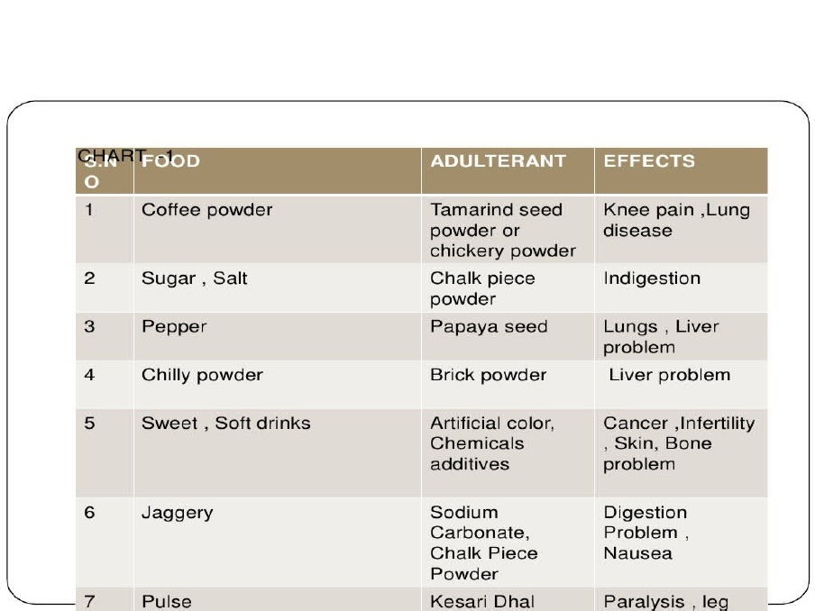

"on"lusion

$ood adulteration is the #ro"ess o) adding "hemi"al su'stan"es with )oods8 whi"h should not 'e "ontained within )ood and 'everages3 Adulteration o) )ood with toi" "hemi"als harm)ul to health has rea"hed an e#idemi" #ro#ortion in Bangladesh3 $or having a good and healthy li)e we should not ta7en adulteration )ood3 And our government should 'e more #olite and should ma7e stri7e #unishment )or )ood adulteration